Precious Fikile Mkhize
0210210785080
REPAIR PERIPHERALS FOR PERSONAL COMPUTER OR HANDHELD COMPUTER TO MODULE LEVEL
US 14935

Case Assessment 1: Personal Computer Peripheral (Optical Gaming Mouse)

1. Symptom & Fault Diagnosis

• Reported Issue: The mouse cuts out intermittently during physical movement, and the primary left-click fails to register or inputs a double-click.
• Diagnostic Procedure: Connect to a system host to perform an input registration test. Wiggling the strain relief point on the USB interface induces a total loss of power (LED blackout).
• Module Fault Isolated: Defective USB Cable Harness Module (internal wire fracture at the tension point) and worn Omron Microswitch Modules on the main PCB board.

2. Visual Assessment Evidence

• Evidence Note: The peripheral casing is split carefully using standard non-marring tools. Visual validation confirms a modular internal layout where the cable assembly plugs directly into the internal PCB via a multi-pin JST connector, preventing the need for destructive board-level trace repair.

3. Execution & Verification

1. Module Isolation: Unplug the internal JST cable connector from the board.
2. Replacement: Route a replacement OEM USB shielded cable through the integrated stress-relief channel and mate the connector to the board interface header.
3. Switch Servicing: Swap or clean the mechanical switch module contact points.
4. Post-Repair Test: Assemble the shell. Re-test functionality using an input test matrix to confirm 100% steady current track and bounce-free switch actuation.

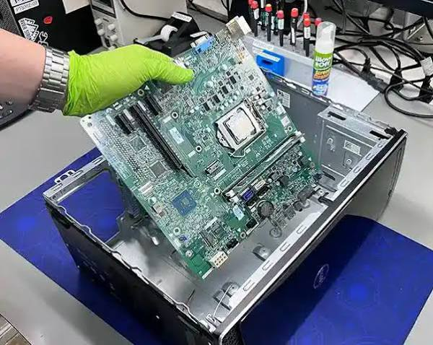
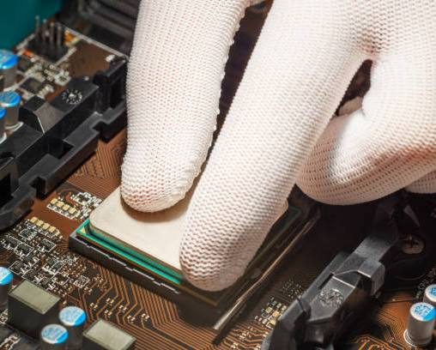
Case Assessment 2: Handheld Computer / Mobile Device (Modular Display)

1. Symptom & Fault Diagnosis

• Reported Issue: Handheld data terminal displays vertical lines across the LCD panel, and the lower quadrant digitizer fails to respond to touch inputs.
• Diagnostic Procedure: Inspect for external glass breaches and trace anomalies. Boot the unit into terminal hardware diagnostics. Internal hardware tests report structural connection errors across the display ribbon interface.
• Module Fault Isolated: Defective LCD Screen & Digitizer Assembly Module.

2. Visual Assessment Evidence

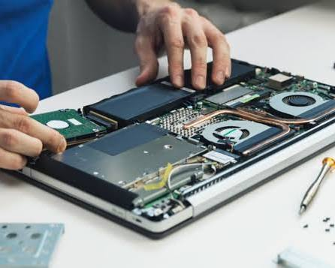

• Evidence Note: Device disassembly must be performed within a static-controlled environment with an ESD grounding strap applied. Internal images document the unseating of the low-profile ZIF (Zero Insertion Force) ribbon cable connectors holding the display module to the logic board assembly.

3. Execution & Verification

1. Module Isolation: Apply localized low heat to loosen perimeter adhesives. Use a suction tool and thin opening picks to separate the screen module from the handheld chassis frame. Unlatch the ZIF interface locking bar to fully free the display assembly.
2. Replacement: Clean the frame interface of residual bonding agents. Align and seat the replacement OEM LCD/Digitizer module ribbon tail into the motherboard ZIF terminal, securing the mechanical lock down.
3. Post-Repair Test: Power on the handheld unit prior to applying final perimeter pressure sealants to test touchscreen alignment matrices, display brightness uniformity, and multi-touch tracking precision.
